**20.6.1 LVM Concepts**

The steps to implement LVM include the following:

1. Connect the physical devices to the system.
2. Use pvcreate to convert the desired devices into physical volumes, which will allocate them for inclusion in the LVM scheme. This will write a header to the physical device and make them visible to the LVM process.
3. Use vgcreate to incorporate all of the desired physical volumes into a virtual collection called a volume group. The volume group now will act as a multi-disk equivalent of a physical volume on which partitioning can occur.
4. Use lvcreate to create the LVM version of disk partitions (called logical volumes) in the volume group created previously. The logical volumes act like partitions in that the user can create filesystems on them, mount them, and in general use them as a traditional partition.

The main advantages of using LVM in general and logical volumes, in particular, is the ability to group together space from multiple physical devices, resize them (as well as the filesystems on them), and much more.

To develop a better understanding of how these steps work, consider a situation in which three new hard drives are added to the system: /dev/sdb, /dev/sdc, and /dev/sdd.

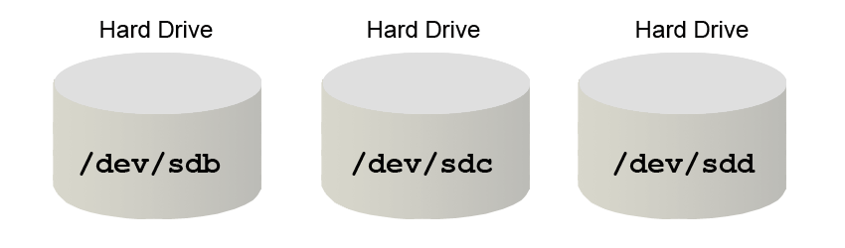

At this point, they are just three hard drives that don't have anything on them, including a partition table. To use these as part of LVM, first execute the pvcreate command on each one:

**root@localhost:~#** pvcreate /dev/sdb

**root@localhost:~#** pvcreate /dev/sdc

**root@localhost:~#** pvcreate /dev/sdd

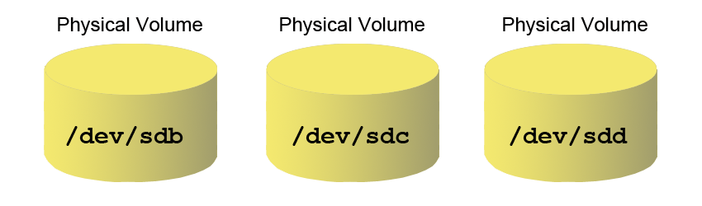

Initially, these hard drives won't appear to be any different. However, there is now a small block of data, called a *header*, in the very beginning of each that defines each device as a physical volume.

The next step is to create a volume group that consists of these three physical volumes. This can be accomplished with the following command:

**root@localhost:~#** vgcreate vol1 /dev/sdb /dev/sdc /dev/sdd

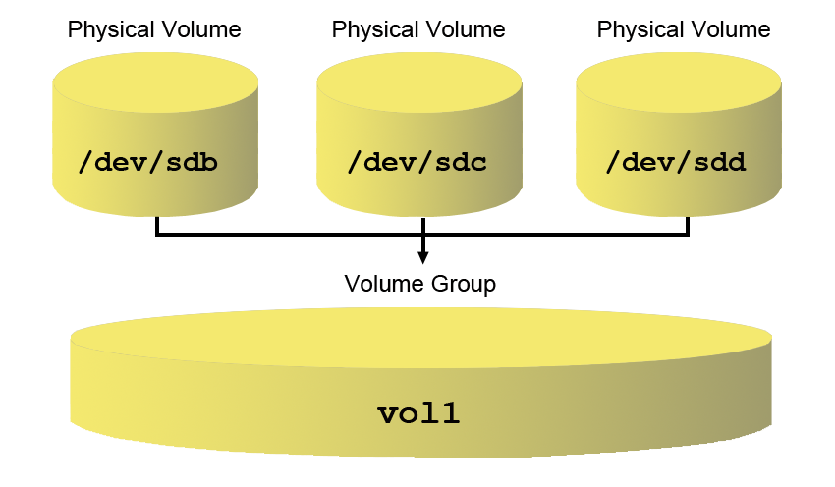

What this now means, is that all of the space from all three physical volumes can be used to create logical volumes. If /dev/sdb is 50GB, /dev/sdc is 20GB, and /dev/sdd is 10GB, a single logical volume could be created that is 80GB in size. Additionally, if another physical volume was added to the system (add a new hard drive, use the pvcreate command, and then a command called vgextend), then this new space could be used to create more logical volumes or add to the size of existing logical volumes.

Any of the space in the vol1 volume group can be used to create a logical volume with a command like the following:

**root@localhost:~#** lvcreate -L 200M -n logical_vol1 vol1

The -L option is used to specify the size of the logical volume. The value of 200M means *create a 200MB logical volume*. The -n option is used to provide a name to the logical volume. The resulting name of the logical volume created by the previous command will be logical_vol1. The last argument, vol1, is the name of the volume group from where the logical volume will obtain its physical space. The previous lvcreate command would result in a new device name of /dev/vol1/logical_vol1 that could be used just like a traditional partition.

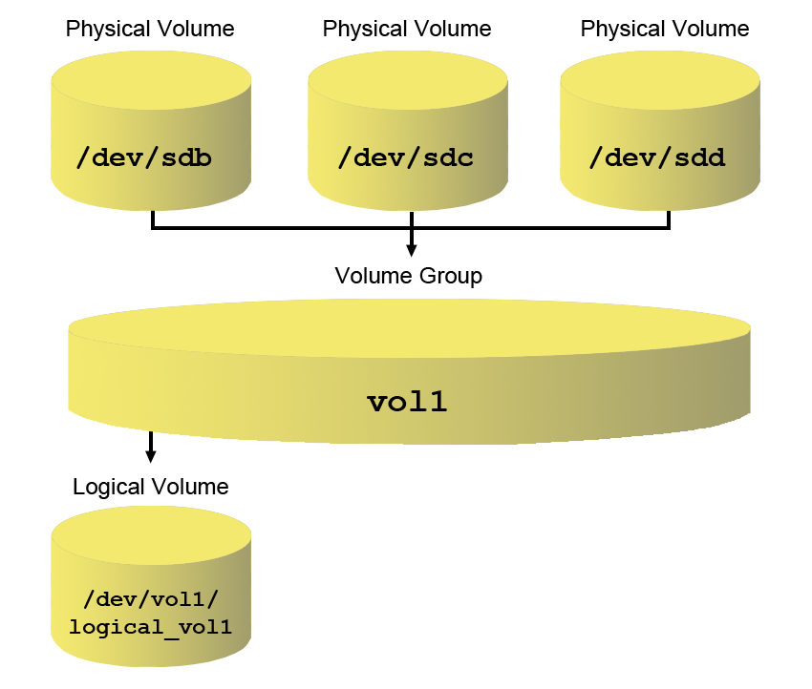

For Red Hat-based systems, the graphical tool system-config-lvm not only simplifies the process of working with LVM, it also helps to visualize what is happening:

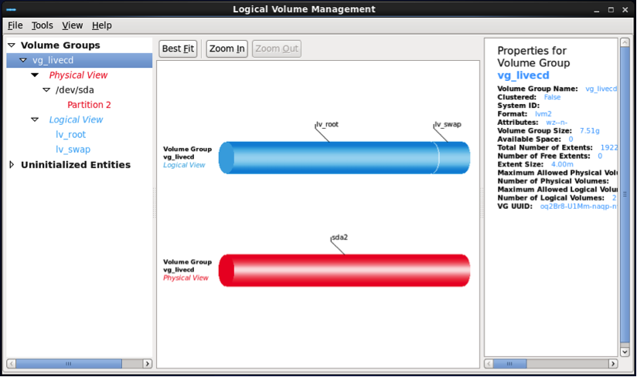

Keep in mind that this tool may not be available as it is not part of the base operating system, but may be part of an optional add-on software package.